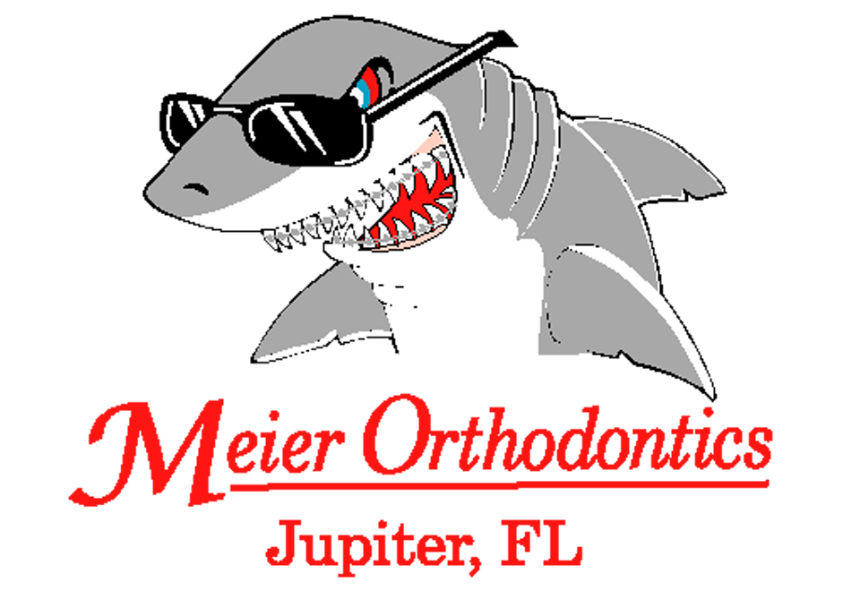

We would like to welcome you to our office. Our goal is to make your visit pleasant and educational. We strive to teach good oral care that will enable you to have a beautiful smile that lasts a lifetime.

ABOUT YOU

Today’s Date:_____________________________________________
Name:____________________________________________
Preferred Name:__________________________________________
Home Address:____________________________________
________________________________________________________
City State Zip

Birth date:______/______/______ Age:__________________
Home #:___________________________________________

General Dentist:__________________________________________

Date of Last Visit:_________________________________________

WHOM MAY WE THANK FOR REFERRING YOU?

________________________________________________________

Person Responsible for Account

Name:________________________ Relation:________________________
Address:______________________________________________________

_____________________________________________________________
City State Zip

WK#_________________________ HM#___________________________
Employer:_____________________________________________________
SS #:_________________________________________________________

In the event of an emergency, whom should we contact?
Name:_______________________________Relation:_________________

WK#__________________________HM#___________________________

Primary Dental Insurance
Orthodontic Coverage? Yes No
Insured’s Name:_________________________________________________
Relationship to Patient:___________________________________________
Insured’s Birthday:____/____/____ Social Security #: __________________
Insured’s Employer:______________________________________________
Employer’s Address:_____________________________________________
Insurance Co. Name:_____________________________________________
Insurance Co. Address:___________________________________________
Insurance Co. Phone #:___________________________________________
Group # (Plan, Local or Policy #):__________________________________

Secondary Dental Insurance
Orthodontic Coverage? Yes No
Insured’s Name:________________________________________________
Relationship to Patient:___________________________________________
Insured’s Birthday:____/____/____ Social Security #:__________________
Insured’s Employer:_____________________________________________
Employer’s Address:_____________________________________________
Insurance Co. Name:_____________________________________________
Insurance Co. Address:___________________________________________
Insurance Co. Phone #:___________________________________________
Group # (Plan, Local or Policy #):__________________________________

What are the main concerns that you
would like braces to accomplish?

__________________________________________
__________________________________________

Continued on Next Page

Have you ever been evaluated or had orthodontic treatment before?
YES NO
Have there been any injuries to the face, mouth, teeth or chin?
YES NO
Have the adenoids or tonsils been removed?
YES NO
Have you ever been informed of any missing or extra permanent teeth?
YES NO
Do you now or have you ever experienced pain/tenderness in your jaw joint (TMJ/TMD)? YES NO
Your current dental health is:
Good Fair Poor
Have you ever had a serious/difficult problem associated with any previous dental work?
YES NO
Please describe your physical health:
Good Fair Poor
Are you currently under the care of a physician?

YES NO
If yes, please explain:______________________________________________________________________________________________________________________

Please list all drugs, including over-the-counter medications, that you are currently taking________________________________________________
_____________________________________________________________
Please list all drug allergies_______________________________________
_____________________________________________________________

Do you or did you currently have any of the following Habits?
Y N Thumb / Finger Sucking Y N Mouth Breathing
Y N Lip Sucking/Biting Y N Speech Problems
Y N Clenching/Grinding Y N Nail Biting
Teeth
Y N Tongue Thrust

Have you ever had any of the following medical problems?
Y N Seasonal Allergies Y N Bone Disorders
Y N Allergies to Plastic Y N Cerebral Palsy
Y N Allergies to Latex/Metals Y N Hemophilia
Y N Diabetes Y N Abnormal Bleeding
Y N Rheumatic Fever Y N Convulsions/Epilepsy
Y N Heart Murmur Y N HIV +/AIDS
Y N Congenital Heart Defect Y N Cancer
Y N Heart Attack/Stroke Y N Difficulty Breathing
Y N Heart Surgery/Pacemaker Y N Sinus Problems
Y N Mitral Valve Prolapse Y N Shingles
Y N Artificial Valves Y N Fever Blisters
Y N High/Low Blood Pressure Y N Headaches
Y N Blood Transfusion Y N Ulcers/Colitis
Y N Anemia/Radiation Treatment Y N Emphysema/Glaucoma
Y N Surgeries Y N Kidney/Liver Problems
Y N Hospitalizations Y N Cleft Lip/Cleft Palate
Y N Asthma Y N Handicaps/Disabilities
Y N Hepatitis Y N Hearing Impairment
Y N Tuberculosis Y N Emotional Problems
Y N Mono Y N Endocrine Problems
Y N Arthritis Y N Nutritional Problems
Y N Thyroid Disease Y N Fainting or Dizziness

Please discuss any medical problems that you have had:__________
_____________________________________________________________________________________________________________________________________________________________________________________________

I understand that the information that I have given is correct to the best of my knowledge, that it will be held in the strictness of confidence, and it is my responsibility to inform this office of any changes in my medical status. I authorize the orthodontic staff to perform the necessary dental services that I may need. I understand that where appropriate, credit bureau reports may be obtained.

__________________________________________________
Signature of Patient Date

